

FACULTY OF TECHNOLOGY AND ENGINEERING
DEVANG PATEL INSTITUTE OF ADVANCE TECHNOLOGY AND RESEARCH
DEPARTMENT OF INFORMATION TECHNOLOGY

A.Y. 2026-27 [SEMESTER 3]

LAB MANUAL

CEUE203: Object Oriented Programming


Practical 3

Object equality and hashing
Problem Statement:
1. Distinct points: override toString, equals, and hashCode; count distinct coordinates in a Point array.
2. Duplicate card check: compare cards by rank and suit and report the first duplicate.
3. Fractions: reduce fractions to lowest terms and compare equivalent values.
Expected Output: The sample programs demonstrate the required behavior; see the captured console output below.

Solution:

Card.java
import java.util.Objects;
public final class Card {
private final String rank;
private final String suit;
public Card(String rank, String suit) {
this.rank = Objects.requireNonNull(rank);
this.suit = Objects.requireNonNull(suit);
}
@Override
public String toString() {
return rank + " of " + suit;
}
@Override
public boolean equals(Object other) {
return this == other || other instanceof Card card
&& rank.equals(card.rank) && suit.equals(card.suit);
}
@Override
public int hashCode() {
return Objects.hash(rank, suit);
}
}

CardDemo.java
public class CardDemo {
public static void main(String[] args) {
Card[] cards = {new Card("King", "Hearts"), new Card("Ace", "Spades"),
new Card("Ace", "Spades"), new Card("Queen", "Clubs")};
Card[] seen = new Card[cards.length];
int count = 0;
for (Card card : cards) {
boolean duplicate = false;
for (int i = 0; i < count; i++) {
if (card.equals(seen[i])) {
duplicate = true;
System.out.println("Duplicate found: " + card);
break;
}
}
if (!duplicate) seen[count++] = card;
}
}
}

Fraction.java
import java.util.Objects;
public final class Fraction {
private final int num;
private final int den;
public Fraction(int numerator, int denominator) {
if (denominator == 0) throw new IllegalArgumentException("Denominator cannot be zero.");
int sign = denominator < 0 ? -1 : 1;
int gcd = gcd(Math.abs(numerator), Math.abs(denominator));
num = sign * numerator / gcd;
den = Math.abs(denominator) / gcd;
}
private static int gcd(int a, int b) {
while (b != 0) {
int remainder = a % b;
a = b;
b = remainder;
}
return a == 0 ? 1 : a;
}
@Override
public String toString() {
return num + "/" + den;
}
@Override
public boolean equals(Object other) {
return this == other || other instanceof Fraction fraction
&& num == fraction.num && den == fraction.den;
}
@Override
public int hashCode() {
return Objects.hash(num, den);
}
}

FractionDemo.java
public class FractionDemo {
public static void main(String[] args) {
Fraction half = new Fraction(1, 2);
Fraction[] equivalent = {new Fraction(1, 2), new Fraction(2, 4), new Fraction(3, 6)};
for (Fraction fraction : equivalent) {
System.out.println(fraction + " equals 1/2: " + fraction.equals(half));
}
}
}

Point.java
import java.util.Objects;
public final class Point {
private final int x;
private final int y;
public Point(int x, int y) {
this.x = x;
this.y = y;
}
@Override
public String toString() {
return "(" + x + ", " + y + ")";
}
@Override
public boolean equals(Object other) {
return this == other || other instanceof Point point && x == point.x && y == point.y;
}
@Override
public int hashCode() {
return Objects.hash(x, y);
}
}

PointDemo.java
public class PointDemo {
public static void main(String[] args) {
Point[] points = {
new Point(1, 2), new Point(3, 4), new Point(1, 2),
new Point(5, 6), new Point(3, 4)
};
int distinct = 0;
for (int i = 0; i < points.length; i++) {
boolean appeared = false;
for (int j = 0; j < i; j++) {
if (points[i].equals(points[j])) {
appeared = true;
break;
}
}
if (!appeared) distinct++;
}
System.out.println("Distinct: " + distinct);
}
}

MiniBank Project Work:

MiniBank progress ? Practical 3
Completed: readable Account output and equality by account number, plus Customer Address and clone support. The full project later carries these model classes forward as additional practical features are added.
Single project location: Java Programs\Minibank

Progressive source excerpts:

Minibank/src/main/java/minibank/model/Account.java ? object equality
public final boolean equals(Object other) {
return this == other || other instanceof Account account
&& accountNumber.equals(account.accountNumber);
}

Minibank/src/main/java/minibank/model/Account.java ? hash code
public final int hashCode() { return accountNumber.hashCode(); }

Minibank/src/main/java/minibank/model/Account.java ? readable output
public String toString() {
return accountNumber + " | " + ownerName + " | " + getBalance();
}

Minibank/src/main/java/minibank/model/Customer.java ? customer clone
public Customer clone() {
try {
Customer copy = (Customer) super.clone();
if (address != null) copy.address = address.clone();
return copy;
} catch (CloneNotSupportedException exception) {
throw new AssertionError(exception);
}
}

Minibank/src/main/java/minibank/model/Customer.java ? nested Address
public static final class Address implements Serializable, Cloneable {
private static final long serialVersionUID = 1L;
private final String line;
private final String city;
private final String pincode;
public Address(String line, String city, String pincode) {
this.line = Objects.requireNonNull(line);
this.city = Objects.requireNonNull(city);
this.pincode = Objects.requireNonNull(pincode);
}
public String getLine() { return line; }
public String getCity() { return city; }
public String getPincode() { return pincode; }
@Override public Address clone() {
try { return (Address) super.clone(); }
catch (CloneNotSupportedException exception) { throw new AssertionError(exception); }
}
}
}

Output Screenshot:
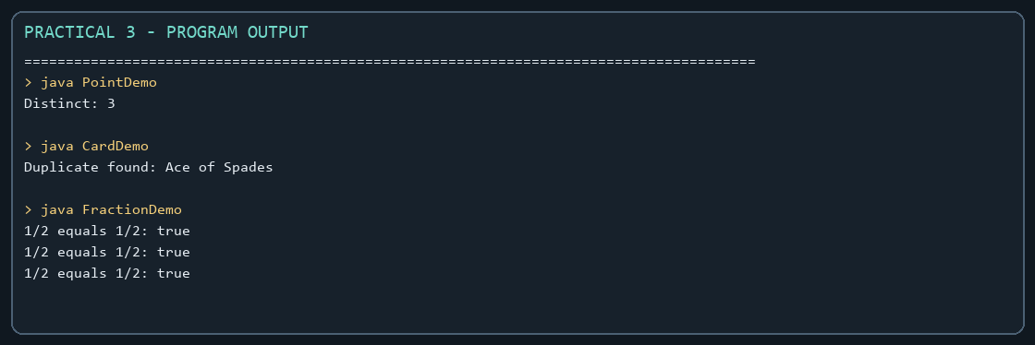
Captured from the compiled practical programs.

